School Beverage Container Recycling Challenge

The ‘Collier County School Beverage Container Recycling Challenge’ grant (attached) ranked 7th out of 19 Florida Innovation Grants certified by the Florida Department of Environmental Protection. This innovation grant is based on the successful America Beverage Association marketing program ‘We got plans for your bottles and cans’ Student volunteers are needed for each of the following areas of student recycling competition:

A. Student videos lip syncing the American Beverage Association (ABA) ‘We got plans for your bottles and cans’ ads in the categories of Rock, Hip Hop, Country and Spanish (www.recycleitnow.net). The Spanish songs are available on CD disk the County will provide to the winning vendor.

B. Student created ‘We got plans for your bottles and Cans’ Music Videos.

C. Student created 30-60 second Television commercials with recycling themes ‘We got plans for your bottles and Cans’ a recycling reincarnation theme (http://www.re3.org/flicks.htm and http://www.getcaughtrecycling.org/brdcst_downloads.htm ).

D. Student recycling beverage containers poster contest emphasizing reincarnation of beverage containers to other products: www.recycleitnow.net and http://www.americarecyclesday.org jimmyo@nrc-recycle.org and http://www.floridadep.com/waste/categories/recycling/AR/2006/ar06.htm.

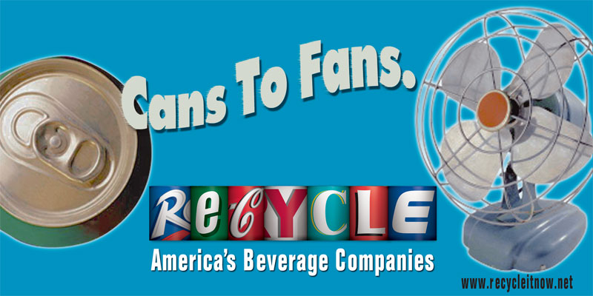
E. Competition between the categories of High, Middle and Elementary Schools on which School can save the most recyclables.
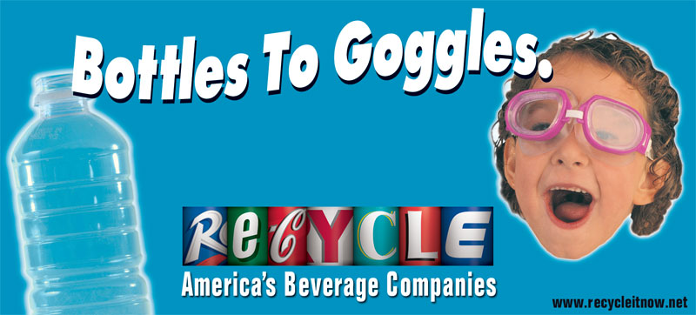
Contact: davidjaye@colliergov.net 239-732-2508

