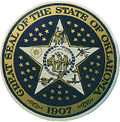State Seal of the State of Oklahoma
OKLAHOMA
Korea Representative of Oklahoma: http://www.ok-topia.com/
Department of Commerce: http://www.odoc.state.ok.us/
The Official State Website: http://www.oklaosf.state.ok.us/

- Oklahoma Facts
- The State Capital: Oklahoma City
- Oklahoma: “okia” meaning people + “humma” meaning red
= Red People
- The Largest American Indian population of any state
39 of the American Indian tribes currently living in Oklahoma
- The 3rd largest natural gas-producing state
- The 4th in the nation in the production of all wheat, 4th in cattle and calf production, 5th in the production of pecans, 6th in peanuts and eight in peaches
- Two main airports are Oklahoma City (OKC) and Tulsa (TUL)
Amtrak operates a line from Oklahoma City to Fort Worth, Texas
2. Climate
- Bright and Sunny
- The average annual temperature is 59.9°F(15.5 degrees C)
- Four distinct seasons and winters
- 300 days of sunshine per year
3. Population
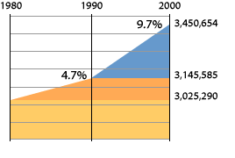
- Growth
- Oklahoma grew 9.7 percent since 1990, more than double its growth over the last 10 years.
- Oklahoma ranks 27th in the nation in population.
- Diversity
  - Oklahoma has more American Indians than any other state.
  - Nationally, 2.4% of the population report themselves as two or more races. In Oklahoma that average is 4.5%.
  - People of Latin origin more than doubled from 1990 to 2000, from 86,160 to 179,304

- Market Proximity
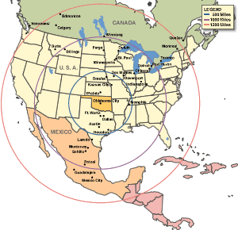

- Bordered by six state
- Texas to the south and west, Arkansas and Missouri to the east, Kansa to the north and Colorado and New Mexico at the tip of the northwestern Oklahoma panhandle
- Equidistant between Los Angeles, New York City and Mexico City, more than 75 million people live within a 500-mile radius of the state
- Easily shipping and receiving products and resources by land, air, rail and waterway

- Cost of Doing Business
Oklahoma offers tremendous cost savings. Labor and energy costs are all well below the national average, and Oklahoma is consistently one of the lowest per capita taxed states in the nation. Overall, Oklahoma's total business costs rank fourth lowest in the U.S.
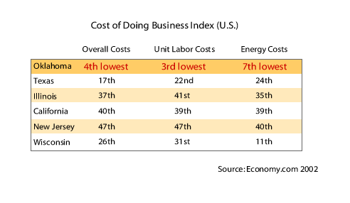
- Cost of Living
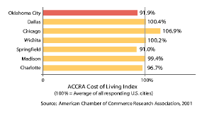
- Cost of Housing
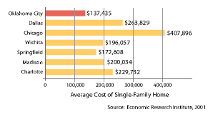

- Cost of Construction
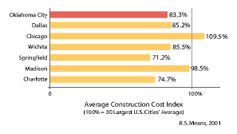

Economy.com ranked Oklahoma as the third least expensive state in the nation to do business.
Oklahoma’s unit labor cost index is fourth lowest in the nation. Oklahoma’s industrial power, real estate and construction costs rank among the lowest in the county.

- Economy
- If Oklahoma were a country, gross state product would rank as 51st largest in the world.
- Oklahoma is home of over 150 Fortune 500 facilities.
- Oklahoma is more diversified than ever before – with employment in such technologically advanced fields as aviation, electronics, telecommunications, biotechnology, plastics, business services, fabricated metals, agriculture and energy.
- Oklahoma’s aviation and aerospace industry employs over 143,000 workers and generates 10 percent of the state’s industrial output.
- Oklahoma is the largest tire producing state in the country, with major Goodyear, Michelin North America and Dayton production facilities.
- Advantages of locating a business in Oklahoma
- The superior workforce
Labor surveys conducted statewide show a significant population of underemployed meaning there is an abundance of workers who are willing and able to change their employment to capitalize on new opportunities .

- Premier Training System
Technical education system provides free customized start-up training to qualified firms through the Training for Industry Program. It has been a key factor in the successful recruitment of several companies, including Farmers Insurance, Quad Graphics, Dollar Tree and Huber Engineered Woods.

- Small Employer Quality Jobs Program
The Oklahoma Small Quality Jobs Program rebates quarterly cash incentive payments to qualifying companies. The program reimburses quarterly cash payments of 3-5% of new taxable payroll directly to a qualifying company, for up to seven years. Qualifying companies must also maintain these jobs for seven years and have no more than 90 full-time employees at the time of the application.
In addition, companies must pay all new full-time jobs annual salaries that at least 110% to 125% of the average wage of the county in which the jobs are located.
Qualifying companies generally must be manufacturers or service companies. At least 75% of its sales must be to out of state customers, the federal government, or to in state customers for out of state resale.
- Incentives
- Easy
Oklahoma's state business incentives are simple, straightforward and statutory.
- True Tax Credits
State tax credits are 100 percent usable in Oklahoma. The state's alternative five percent investment or $2,500 per new job income tax credits can be used to offset 100 percent of state income tax liability each year.
- Business Friendly
Oklahoma's award winning Quality Jobs incentive gives qualifying enrolled companies quarterly rebates of up to five percent of taxable wages for up to 10 years. Since inception, the state has committed over $1.5 billion of incentive payments to more than 300 companies. Over 260 companies have already received more than $300 million in wage rebates. Currently the quality jobs program pays benefits on more than 35,000 new jobs in the Oklahoma economy.
- Special Federal Tax Treatment
Two-thirds of Oklahoma, because of its unique history, qualifies for special federal tax treatment. All firms in qualifying lands are entitled to utilize accelerated depreciation schedules on their federal income taxes. In addition, firms in the area that hire Native Americans or their spouses also qualify for federal income tax credits. With tax liability, this accelerated depreciation is worth in present value terms three to four percent of the cost of investment compared to a non-qualifying location.

