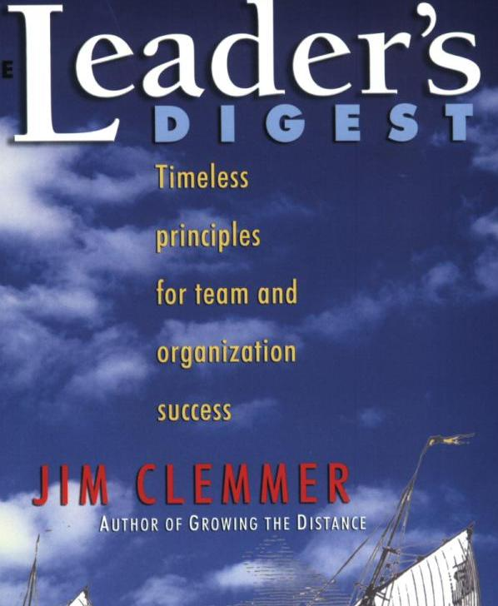
input.doc

The Leader’s Digest:

Timeless Principles for

Team and Organization

Success

Year of publication: 2003

By Jim Clemmer

‘Rosa’ Shin-Young Kim
김신영
Business Administration
Mobile Phone: 82-17-858-2378
E-mail: n_2gether@hotmail.com
Due date: 4-11-05

Leader’s digest is intended to show us about timeless leadership principles which leaders can use to be more effective in our personal and professional lives. And this book is written for anyone who has the responsibility of leading people in an organization – including supervisors, team leaders, managers, and executives. A central theme of the book is that leadership is an action, not a position – each of us, as individuals, need to be leaders, regardless of whether or not we have a formal leadership role. This is where leadership begins – "in here," before moving "out there" to influence, guide, support, and to lead others.

The author has attempted to identify, illustrate, and demonstrate the application of the timeless leadership principles found in the “Leadership Wheel”. So I think when we thoroughly understand this wheel we can almost understand this book and leadership.

Let’s look at this “Leadership wheel”. Leadership begins at the center of our being and develops in multiple directions, each represented by the timeless leadership principles described in this book.
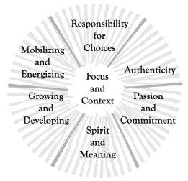
And each part of the wheel corresponds to an area of leadership. At the hub of the wheel, we have the vision, values, and purpose with which leaders effectively focus their teams and organizations on the core of their being (Focus and Context).
Leaders also take initiative and do what needs to be done rather then waiting for "them" to do something (Responsibility for Choices).
Leaders are authentic and lead by visible example, fostering openness and continuous feedback (Authenticity).
Leaders are passionate and build strong commitment through involvement and ownership (Passion and Commitment).
Leaders lead with heart and rouse team or organizational spirit (Spirit and Meaning).
Leaders grow people through strong coaching and continuous development (Growing and Developing).
Finally, leaders energize people by building strong teams, inspiring, and serving (Mobilizing and Energizing).

The wheel model provides a metaphor for situations faced by an organization. For example, just as a wheel's weight-bearing ability depends upon the strength of its hub, so too does the strength of an organization's hub (or core values) determine the weight of the performance and change issues that it is able to carry.
The wheel also represents the circular nature of leadership – there is no beginning or end. Each of the supporting leadership principles around the outside of the Leadership Wheel is interdependent and interconnected. If our team or organization develops all the leadership skills, the wheel is well-rounded. If it is deficient in one or more of these skills, the ride may be a little bumpy.

After I read many reviews about this book, I stated to think about would these principles in this book be useful in Korea? Absolutely! Thomas Henry Huxley, the 19th-century English biologist, once said that "All truth, in the long run, is only common sense clarified." Leadership is really just common sense. I agree with that. And he said the problem for most of us is that it's not common practice. Thus we should remind us all of common-sense principles where the practicing may be slipping.

And also we need to continually review the timeless lessons about leadership for today's circumstances.

Reference
http://www.clemmer.net/books/tld.shtml

