Mike Armstrong
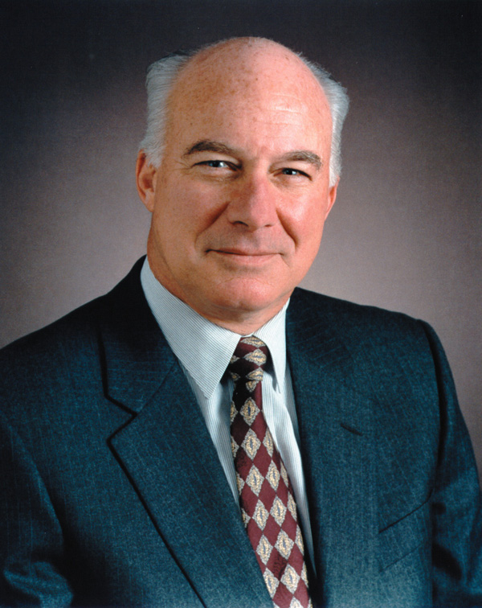
 Mike Armstrong was named AT&T’s new chairman and CEO in October 1997. He had run Hughes Electronics (which founded satellite television operator Direct TV) and was IBM’s Group Executive, Communications, understood the telecommunications industry. He spent about three decades at IBM and restructured the company’s operations in Europe.


 Five Principles of Business Leadership

Have a defining idea.
His defining idea was for AT&T to move to facilities-based broadband communications.
AT&T would not just sell narrow-band long distance service, they would operate through broadband wireless, Internet, and cable. In short, AT&T is the only communications provider a customer will ever need.

Have the courage to be competitive.
Armstrong says, to be competitive, dramatic moves such as reorganizations, reduction of the workplace are mandatory. These moves make the industry more competitive.

Communicate!
Understand, respect, and trust his or her management team. Business is like sports. The team that plays together best gets the Super Bowl ring. So the leaders cannot change a culture and entire management team.

Must do involves decision-making.
Businesses are not democratic institutions. Some may choose to lead by intelligence, because of the momentum of their success. “You’d better lead by intelligence, instinct, judgment and make decisions while there’s still risk in them.”

Commit to values as you generate both personal and organizational energy.
The leaders have to create excitement as well as opportunity. If they can create that exciting work environment for people, they will work their bloody tails off for the leaders.

