 (Dell Corporate Communications)
http://www.dell.com/
One focused vision made Dell the world's leading direct computer systems company, with approx. 38,200 employees in 34 countries around the globe. One bold concept-direct customer contact-has made Dell one of the most successful companies of the 1990s.
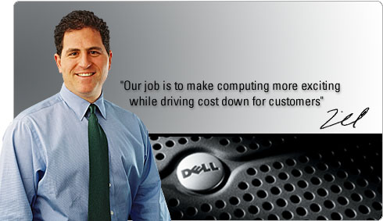Michael S. Dell, born in February 1965, is the founder, the chairman and chief executive officer of Dell Computer Corporation, the company he founded in 1984 with $1,000 and an unprecedented idea in the computer industry: sell computer systems directly to customers. Michael is also the longest tenured CEO in the computer industry. Under Michael's direction, Dell has established itself as the world's most preferred computer systems company and is a premier provider of products and services required for customers to build their information-technology and Internet infrastructures.
The latest global innovation to come from Dell is its leadership on the Web. Dell is acknowledged as the largest online commercial seller of computer systems. The company also is redefining the role of the Web in delivering faster, better and more convenient service to customers.

The company's corporate customers include many of the companies in the Fortune 500 list of the largest American companies. With the addition of Dell to this list in 1992, Mr. Dell became the youngest CEO of a company ever to earn a ranking on the Fortune 500.Mr. Dell is a member of the executive committee of the World Business Council, a vice chairman of the U.S. Business Council, and the chairman of the Computer Systems Policy Project, an affiliation of CEOs from top computer companies that advocates public policy positions on trade and technology affecting the computer industry. He also serves on the U.S. President's Council of Advisors on Science and Technology.

What do you learn the lesson from Michael Dell?
- Evolutional distribution channel: directing sell (without the dealer)
- Continuing the R & D for customer’s demand and technical development
- Supporting the interaction between the seller and customer

