April 2nd 2003, Professor Dave Jaye’s <American Business Practices and Culture>
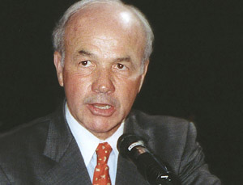
KEN LAY
Enron
The $30 billion corner store

Enron, the largest buyer and seller of natural gas and electricity in the United States, builds and manages energy facilities worldwide. However, Enron is, at the moment, in the midst of restructuring its business with the hope of emerging from bankruptcy as a strong and viable, albeit smaller, company.

Ken Lay’s achievement, idea, and strategies
- Kenneth L. Lay has done in taking his company into new countries, new businesses, and into executing new business strategies → a new way of thinking about the energy business is involved.
- Lay has constantly pushed for deregulation in spite of other CEOs’ opposition.
- Lay put a lot of emphasis on the value system and on the importance of the individual. The company employees worked hard to create an environment that is conducive to individuals communicating.
- To give employees and the company more opportunities, Lay has aggressively moved Enron into non-regulated businesses.
- He integrated the two different parts of the business → One of the ways to achieve that integration is by shifting people from one side of the business to the other.
- He has moved people around a lot, including internationally.
- Lay thought everybody in the organization could make a contribution → So, the person at the lowest level of the company can make a difference.

The secrets to Ken Lay’s success
- Creating big pockets of entrepreneurship throughout the company.
- The result of the kinds of people he recruits → Recruiting very smart, very results-oriented, very creative and high performance people.
- He creates an incentive system that rewards employee performance → This is simply the right way run a business.
- Having the responsibility for the right work place environment.
- Providing leadership, having compelling company vision and energizing everybody.

Hong, Youmee (Christine)
Mobile phone: 011-298-0813 E-mail: youmeeh@hotmail.com

