
Howard Schultz
www.starbucks.com
Starbucks
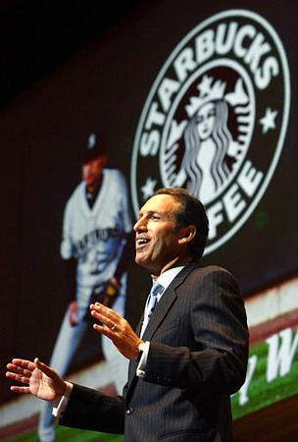
Sharing Success

Howard Schultz, a man raised in poverty, pioneered the transformation from grocery store retail brands to Starbucks specialty coffee stores. This idea occurred to Schultz after he made a trip to Italy and experienced the distinctive ambiance of Italian cafés. Starting out in the mid 80’s with just a few stores, Starbucks currently serves nearly 20 million people a week from nearly 5,000 outlets in 25 countries with a market cap of over 9 billion dollars. Schultz had brought profit back into the coffee industry by implementing multiple sales channels and by redefining coffee from a beverage to an experience.
“I think it’s very difficult to lead today when people are not rally truly participating in the decision. You won’t be able to attract and retain great people if they don’t feel like they are part of the authorship of the strategy and the authorship of really critical issues. If you don’t give people an opportunity to really be engaged, they won’t stay”

Intimacy
Putting his employees first is the best way of achieving the greatest shareholder returns by strengthening the trust between management and the people who do the work.

The Third Place
It’s the comfortable place between home and work, and it’s the one part of the day where people really can get a respite-people can gather, people can meet over coffee, people can have a private moment. It’s more than coffee place.

Competitive Advantage
Starbucks is not immune to competition. However, it decided to provide equity in the form of stock options and comprehensive health care system that’s very unusual to cover even part-timers. If people can come to work feeling totally secure and confident that they have health insurance, that they’re a part of the action and they have a piece of ownership, it would give us a huge competitive advantage.→ The employee benefit package is called Bean Stock
Lessons from the CEO
Values-and culture-based business: Success for a company is maximized when it’s shared. If we want to inspire our customers, we have to inspire our people. There has been a fracturing of trust between senior management and rank-and-file employees. Once trust is broken, the ability to inspire people is over. He takes these kinds of issues very seriously, because Starbucks is such a values-and culture-based business.

